Training Videos on the RLI portal

There are training videos on the RLI portal. Here is the link: https://myportal.rlicorp.com/en/personal-umbrella/resources

The agents do need to log in to the portal to view these videos.

Instructions to videos:
Log in RLI portal
Click on Personal Umbrella drop down
Click on View Product Details
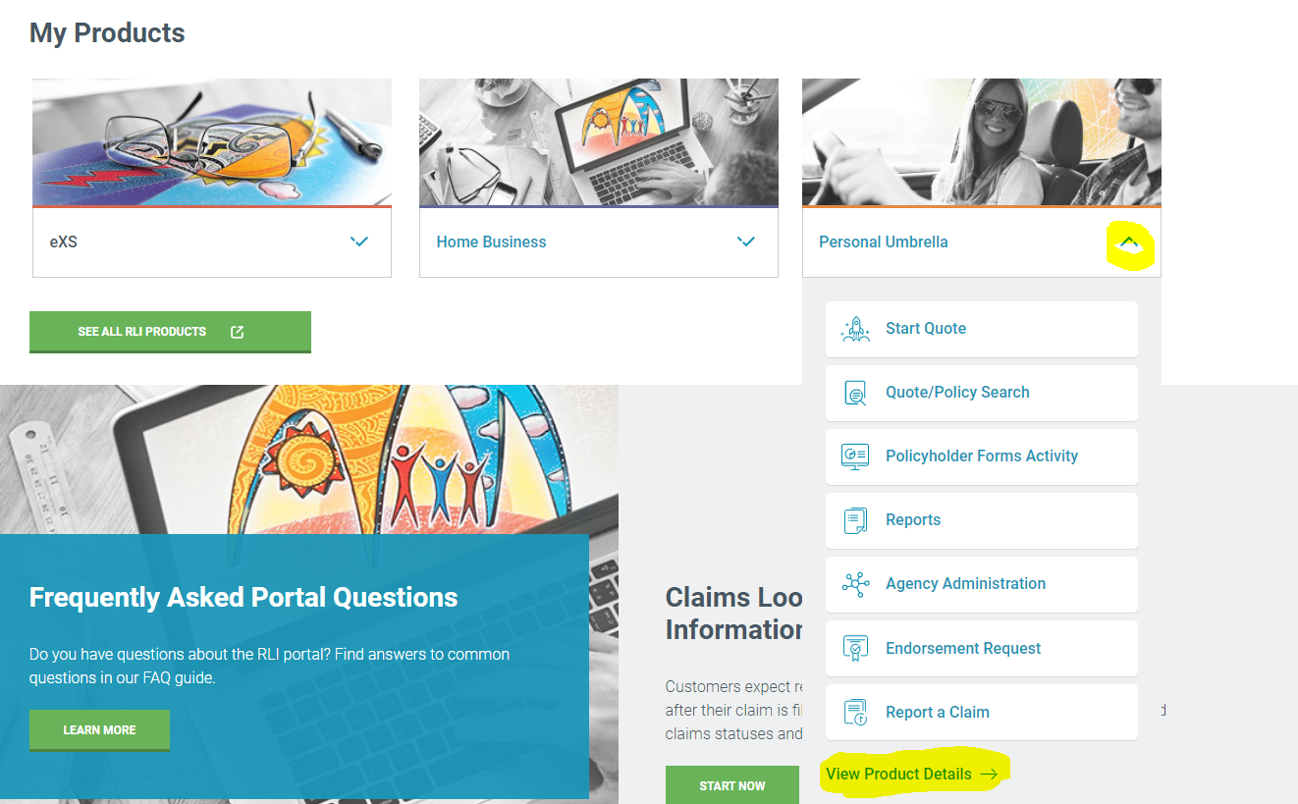

From here you will click on RESOURCES. The videos are at the bottom of the page. There are several.

